Step Detection
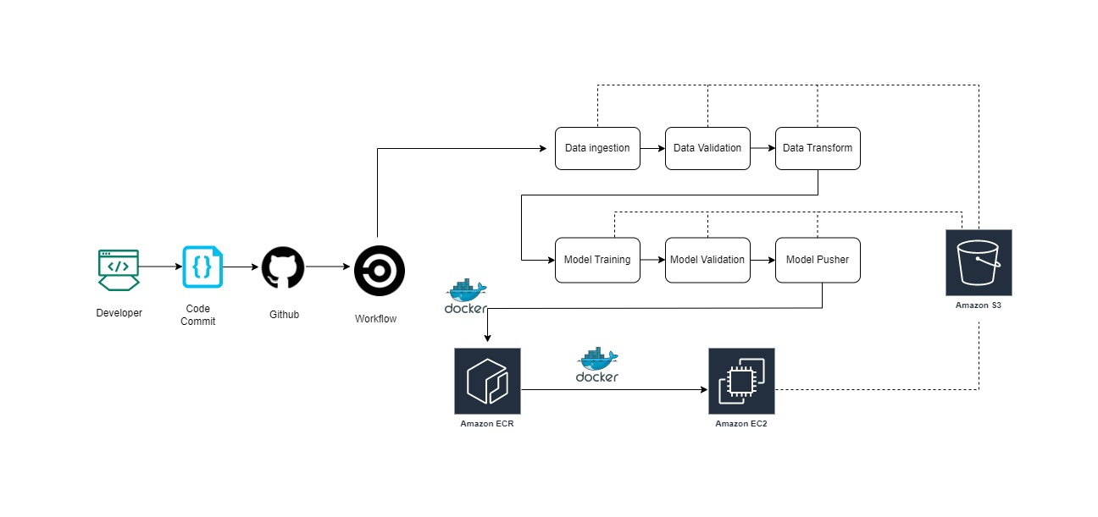
There are 2 types for pipeline currently we have
- Data upload pipeline
- Model Training Pipeline

- Data Upload Pipeline:
In this pipeline we are using S3, ECR and EC2 resources from AWS. Along with AWS we are using Git for code repository and Github actions for triggering pipeline.

List of resource name:
- S3: ds-step-detector
- ECR: ml
- EC2: ml-data-upload

- Model Training Pipeline:
In this pipeline we are taking all of our curated data and performing model training/Tuning.
Git for code repository and Github actions for triggering pipeline. Here we are using only S3 bucket as AWS resource

List of resource name:
- S3: ds-step-detector

